**Spartan Market**

**Team 17**

Maan Singh

Tien Ly

Ge Ou

**Project Description:**

“Make your reading not only reading, but also values!”

The database application we are proposing is titled ‘Spartan Market.’ The application is to serve people who enjoy reading and want to benefit from it. Nowadays, people spend a lot of time on social media and watching videos. Although people can relieve stress when they use these applications, but when they are off, people feel lonely and makes them want to go online again which can lead to an addiction. These forms of entertainment do not bring real happiness to people.

According to Felecia in “10 Benefits Of Reading”, she mentions that reading helps people to learn and improves memory, develop good analytical skills, expand their vocabulary, improve writing skills, relaxation, improve concentration, inspire them, even reading with their kids to increase time with families, improve their language skills, and wrap up. We want to create a platform for people who like to read and make that experience worthwhile for them.

The application would have many kinds of books such as Children’s Books, Novels, Magazines, Textbooks, etc. We also plan on selling school supplies, and swag and we want to make this a go-to application for SJSU students. Unlike the school bookstore, we want to allow users to also sell their textbooks and supplies.

Spartan market should convenience to students and stuff at SJSU to buy whatever they want.

* Stakeholders
  + SJSU Students - The targeted user base for our application are the students of the university, so they serve as the primary stakeholders in this project.
  + Team 17 - As developers of this application, we are heavily invested in this project and we want to be able to have this application used by our fellow students.
  + Professor Wu - Professor Mike Wu will be overlooking our project to completion and will be our best resource if we need anything.

**System Environment**

* + Structure of the system

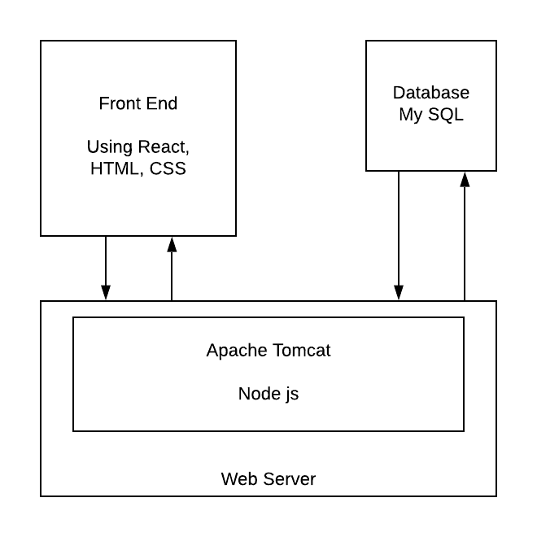

* + Database is MySQL.
  + Languages used is JavaScript.
  + Software for backend is Node.js, Apache HTTP Server, Apache Tomcat
  + Software for frontend is React.js, HTML, CSS.

**Functional Requirements**

* Describe users:

Users can be unregistered or registered users. Unregistered users can browse items on Spartan Market without buy items. Registered users can browse items, buy items, set their delivery information, and payments.

* Users can access the system:
  + create a new account: user ID uses their email address, and password consist with letters and numbers.
  + login using user ID and password
  + forgot password function: if users forget their password, they can change their password using their email.
  + save user’s information: first name, last name, address line, and zip code.
  + save user’s payment: credit card information, store or not store.
  + save user’s cart: items that users put into cart.
  + a search bar for users to find which good they want
* Describe each functionality/features, functional processes and I/O(s).

Items

* + Category (String): kinds of iterms
  + Item ID (Int & primary value): every item has their individual ID
  + Item Name (String)
  + Amount(Int)
  + Price (Double)
  + Producer (String)

Cart

* + Items which users choose
  + The amount of each item

Payment page

* + Items
  + Total payment
  + Enter address to ship
  + Confirm payment method

Map

* + Show our stores in Google Map

Contact us

* + Website information
  + Email to contact

**Non-functional Issues**

* **Graphical User Interface**
  + The Graphical User Interface (GUI) will be designed as an intuitive user-friendly interface allowing easy navigation between multiple web-pages and using simple words for ease of access. The design will be based on these necessary user interface standards for web applications as follows (<https://www.designyup.com/7-user-interface-design-guidelines-for-web-applications/>):
    - Consistency of the Design: The design will have a consistent design layout. To achieve this, similar elements will be used throughout multiple web pages, for example, identical buttons, search bars, fonts, image size, and a homogeneous navigation bar available at the top of each web page. Along with these elements, minimal CSS stylesheets will be used, that will be linked to each web page instead of adding styles to each distinct web page. This will ensure a consistency of the design and will make it easier for a user as he will not need help navigating through the website.
    - Clarity of Layout and Design: Clarity will be achieved by using clear images, proper typography and layout. The design will take into account the white space available in each page and use a layout that is consistent throughout the application to enable easy viewership.
    - Responsiveness:This will be achieved by ensuring speedy navigation within the application without affecting the quality by taking into account the factors that may lead to slow loading times.
    - Familiarity: It is very important to have an intuitive interface that enables an easy access to the application and a quality experience for the user. To accomplish this, the design will have elements that are self-explanatory with clear names on buttons, and similar sizes of these elements throughout.
    - Aesthetics: The color palette used for the application is a very important decision as it is a strong component in the branding of the application. To realize this, complementary colors will be used in the stylesheet, in our example, the Spartan flair - blue and gold.
    - Error Logging: As with most applications, error logging is essential as it not only prevents the user but also informs on what action went wrong for the user. Errors in any application can be very complicated and represent technical errors within the application, but the design should be intuitive enough to send an easy to perceive and concise message.
* **Security**
  + In a web application, security is the most important non-functional requirement as any user has to use personal credentials to login to a web application and the design should make sure that this information cannot be compromised anyhow. To have a user securely login, the design will have an authentication flow, for example, ‘Sign-in with Google’ that authenticates a user by using its servers and propagating through an intuitive and secure protocol called the Google OAuth flow. In the design, this mechanism, will be used along with using SSO services available that use protected protocols like Kerberos to achieve authentication and authorization.
* **Access Control**
  + The application contains personal data of all of its users, but the design will only allow a user to have access to its resources. This will be achieved through the use of ‘cookies’ that keep session data stored inside of it and recognizes a user and its data throughout the session. Apart from session management, there will be admin accounts that have permission to make edits to any listings and even delete spam listings on the application.  In this way, a user that is purchasing an item will not be able to edit any item listing that does not belong to it and can only go through the ‘purchase an item’ flow.
* **Space**
  + The application will use minimal space and it will be designed to ensure that any rows in the database tables are hard deleted and that no orphan rows remain in the table.

**Works Cited**

Smith, Felecia. 10 Benefits Of Reading. Technobezz. August 14, 2018. <https://www.technobezz.com/10-benefits-of-reading/>

7 User Interface Design Guidelines For Web Applications. DESIGNYUP. November 27, 2018.

<https://www.designyup.com/7-user-interface-design-guidelines-for-web-applications/>